UNITED STATES OF AMERICA

PROPOSAL FOR THE WORK OF THE CONFERENCE

Agenda Item 1.5: to consider the use of frequency bands allocated to the fixed-satellite service not subject to Appendices 30, 30A and 30B for the control and non-payload communications of unmanned aircraft systems (UAS) in non-segregated airspaces, in accordance with Resolution 153 (WRC-12)

Background Information: The development of Unmanned Aircraft Systems (UAS) is based on recent technological advances in aviation, electronics and structural materials, making the economics of UAS operations more favorable, particularly for more repetitive, routine and long duration applications. The current state of the art in UAS design and operation is leading to the rapid development of UAS applications to fill many diverse requirements. There are a large variety of existing and envisioned applications of UAS such as cargo transportation, fire-fighting, flood monitoring, search and rescue, disaster operations management, oceanographic and atmospheric observations, weather forecasting, geological survey, monitoring of gas pipelines and electricity distribution systems, city and highway traffic, border patrol, law enforcement, counter drug operations, crop and harvest monitoring, broadcast and airborne relay-type services, as well as, of course, national security purposes. As further evidence of this growth, the United States has recently licensed six UAS research and test site operators across the country, set up a center of excellence (COE) to better understand how UAS can be integrated into the National Airspace System, and developed the first annual UAS Roadmap to address current and future policies, regulations, technologies and procedures that will be required as UAS operations increase in the nation's airspace. Further details on UAS applications in non-segregated airspace can be found in Report ITU-R M.2171.
The operation of UAS outside segregated airspace requires addressing the same issues as manned aircraft, namely safe and efficient integration into the air traffic control system. In the context of this agenda item, a UAS consists of an unmanned aircraft (UA) with an Earth station on-board to interconnect the UA and the associated Earth station of the unmanned aircraft control station (UACS) through a satellite operating in the FSS. UA are aircraft that do not carry a human pilot but that are piloted remotely, i.e. through a reliable communication link. UAS operations up to now have been limited to segregated airspace. However, it is planned to expand UAS deployment outside of segregated airspace.
It is the role of the ITU to address the spectrum and regulatory provisions for the command and control of UAS. It is the role of ICAO to establish the necessary standards and recommended practices (SARPS).

Report ITU-R M.2171 identified the spectrum requirements for unmanned aircraft system (UAS) command and non-payload communication (CNPC) links that would be needed to support flight through non-segregated airspace. Those requirements identified the need for both line of sight (LOS) and beyond line of sight (BLOS) spectrum. While the LOS requirements were addressed at the last World Radiocommunication Conference (WRC) held in 2012, the BLOS requirements were only partially addressed. As a result a new agenda item for the 2015 WRC (agenda item 1.5) was established to investigate whether fixed satellite networks, not subject to Appendix 30, 30A and 30B could be used to provide additional capacity for UAS CNPC links. This agenda item supports the addition of technical and regulatory provisions to enable use of portions of bands allocated to the fixed satellite service (FSS) for UAS CNPC links, provided studies demonstrate compatibility with incumbent services and that the requirements of aviation authorities are satisfied. ITU actions must address providing a regulatory framework for the safe operation of UAS CNPC links in FSS bands under the ITU Radio Regulations and thus obtaining international recognition along with the basis for avoiding harmful interference.

Studies within the ITU-R have provided information on the CNPC radio link performance under various UAS operating conditions. These results along with other information will be used by ICAO in the future as it develops the required communications performance and eventual SARPS for UAS CNPC. Other studies within the ITU-R also address the compatibility between this application of the FSS and other services that may be authorized by administrations. All of these studies, as well as the CNPC performance requirements, can then be used by ICAO to determine the particular UAS CNPC applications and scenarios that may be used safely in the different types of airspace within, and by, each administration. ICAO UAS CNPC SARPS are in the early stage of development.

More than 100 geostationary satellite communication networks operate in frequency bands allocated to the FSS in the bands 10.7-12.75, 13.75-14.5, 17.3-20.2, and 27.5-30.0 GHz. Report ITU-R M.2171 identifies a large variety of prospects for UAS that would need to fly long-distances (worldwide) through airspaces controlled by civil air traffic control (ATC). Immediate access to this globally existing capacity would provide great advantages for UAS fleet operators fostering new applications, enabling faster developments of new markets, while providing planning stability for significant investments. Studies under this agenda item investigated the link feasibilities and sharing conditions for using UAS CNPC links over typical frequency spectrum allocated in several FSS allocations.

Report ITU-R M.2233 contains examples of technical characteristics for UA CNPC including FSS systems operating in portions of the frequency ranges 10.95-14.5 GHz and 17.3-30.0 GHz. These examples indicated that it may be possible to operate UAS CNPC links in these bands while meeting the desired link performance. It is recognized that a further Report may be available by the time of WRC-15.

The U.S. proposal provides a regulatory framework for the safe operation of UAS CNPC links in FSS bands under the ITU Radio Regulations; thus obtaining international recognition along with the basis for avoiding harmful interference. It includes text for a footnote to the appropriate FSS bands which points to a Resolution that spells out the conditions of use for supporting safe and efficient operation of UAS. The deployment of UAS is accelerating. A key component of the ITU’s mandate is to promote the extension of the benefits of new telecommunication technologies to all the world’s inhabitants ITU Constitution, Article 1, Section 1 d.

It is critical that the ITU address the spectrum and regulatory provisions for UAS CNPC links at WRC-15 to extend the benefits of UAS globally.

Proposal:

MOD USA/1.5/1
ARTICLE 5
Frequency allocations
Section IV – Table of Frequency Allocations
(See No. 2.1)

10-11.7 GHz
Allocation to services
Region 1 | Region 2 | Region 3
10.7-11.7  FIXED  FIXED-SATELLITE  (space-to-Earth) 5.441 5.484A ADD 5.XXX  (Earth-to-space) 5.484  MOBILE except aeronautical  mobile | 10.7-11.7  FIXED  FIXED-SATELLITE (space-to-Earth) 5.441 5.484A ADD 5.XXX MOBILE except aeronautical mobile
11.7-14 GHz
Allocation to services
Region 1 | Region 2 |  | Region 3
11.7-12.5  FIXED  MOBILE except aeronautical mobile  BROADCASTING  BROADCASTING-SATELLITE  5.492 | 11.7-12.1  FIXED 5.486  FIXED-SATELLITE  (space-to-Earth) 5.484A 5.488 ADD 5.XXX  Mobile except aeronautical mobile  5.485 |  | 11.7-12.2  FIXED  MOBILE except aeronautical mobile  BROADCASTING  BROADCASTING-SATELLITE  5.492
12.1-12.2
FIXED-SATELLITE
(space-to-Earth) 5.484A 5.488
ADD 5.XXX
 | 5.485 5.489 |  | 5.487 5.487A
 | 12.2-12.7  FIXED  MOBILE except aeronautical  mobile  BROADCASTING  BROADCASTING-SATELLITE  5.492 |  | 12.2-12.5  FIXED  FIXED-SATELLITE  (space-to-Earth) ADD 5.XXX  MOBILE except aeronautical  mobile  BROADCASTING
5.487 5.487A |  |  | 5.484A 5.487
12.5-12.75 | 5.487A 5.488 5.490 |  | 12.5-12.75
FIXED-SATELLITE  (space-to-Earth) 5.484A ADD 5.XXX (Earth-to-space)  5.494 5.495 5.496 | 12.7-12.75  FIXED  FIXED-SATELLITE  (Earth-to-space)  MOBILE except aeronautical  mobile |  | FIXED  FIXED-SATELLITE  (space-to-Earth) 5.484A ADD 5.XXX  MOBILE except aeronautical  mobile  BROADCASTING-  SATELLITE 5.493
…
13.75-14 |  | FIXED-SATELLITE (Earth-to-space) 5.484A  RADIOLOCATION  Earth exploration-satellite  Standard frequency and time signal-satellite (Earth-to-space)  Space research  5.499 5.500 5.501 5.502 5.503

14-15.4 GHz
Allocation to services
Region 1 | Region 2 | Region 3
14-14.25 FIXED-SATELLITE (Earth-to-space) 5.457A 5.457B 5.484A
5.506 5.506B ADD 5.XXX
RADIONAVIGATION 5.504
Mobile-satellite (Earth-to-space) 5.504B 5.504C 5.506A
Space research
5.504A 5.505
14.25-14.3 FIXED-SATELLITE (Earth-to-space) 5.457A 5.457B 5.484A
5.506 5.506B ADD 5.XXX
RADIONAVIGATION 5.504
Mobile-satellite (Earth-to-space) 5.504B 5.506A 5.508A
Space research
5.504A 5.505 5.508
14.3-14.4  FIXED  FIXED-SATELLITE  (Earth-to-space) 5.457A  5.457B 5.484A 5.506 5.506B ADD 5.XXX  MOBILE except aeronautical  mobile  Mobile-satellite (Earth-to-space) 5.504B 5.506A 5.509A  Radionavigation-satellite  5.504A | 14.3-14.4  FIXED-SATELLITE  (Earth-to-space) 5.457A  5.484A 5.506 5.506B ADD 5.XXX  Mobile-satellite (Earth-to-space) 5.506A  Radionavigation-satellite  5.504A | 14.3-14.4  FIXED  FIXED-SATELLITE  (Earth-to-space) 5.457A  5.484A 5.506 5.506B ADD 5.XXX  MOBILE except aeronautical  mobile  Mobile-satellite (Earth-to-space) 5.504B 5.506A 5.509A  Radionavigation-satellite  5.504A
14.4-14.47 FIXED
FIXED-SATELLITE (Earth-to-space) 5.457A 5.457B 5.484A
5.506 5.506B ADD 5.XXX
MOBILE except aeronautical mobile
Mobile-satellite (Earth-to-space) 5.504B 5.506A 5.509A
Space research (space-to-Earth)
5.504A
14.47-14.5 FIXED
FIXED-SATELLITE (Earth-to-space) 5.457A 5.457B 5.484A
5.506 5.506B ADD 5.XXX
MOBILE except aeronautical mobile
Mobile-satellite (Earth-to-space) 5.504B 5.506A 5.509A
Radio astronomy
5.149 5.504A
…

15.4-18.4 GHz
Allocation to services
Region 1 | Region 2 | Region 3
…
17.3-17.7  FIXED-SATELLITE  (Earth-to-space) 5.516  (space-to-Earth) 5.516A 5.516B ADD 5.XXX  Radiolocation | 17.3-17.7  FIXED-SATELLITE  (Earth-to-space) 5.516  BROADCASTING-SATELLITE  Radiolocation | 17.3-17.7  FIXED-SATELLITE  (Earth-to-space) 5.516  Radiolocation
5.514 | 5.514 5.515 | 5.514
17.7-18.1  FIXED  FIXED-SATELLITE  (space-to-Earth) 5.484A  (Earth-to-space) 5.516  MOBILE | 17.7-17.8  FIXED  FIXED-SATELLITE  (space-to-Earth) 5.517  (Earth-to-space) 5.516  BROADCASTING-SATELLITE  Mobile  5.515 | 17.7-18.1  FIXED  FIXED-SATELLITE  (space-to-Earth) 5.484A  (Earth-to-space) 5.516  MOBILE
17.8-18.1
FIXED
FIXED-SATELLITE
(space-to-Earth) 5.484A
(Earth-to-space) 5.516
MOBILE
5.519
18.1-18.4 FIXED
FIXED-SATELLITE (space-to-Earth) 5.484A 5.516B ADD 5.XXX
(Earth-to-space) 5.520
MOBILE
5.519 5.521

18.4-22 GHz
Allocation to services
Region 1 | Region 2 | Region 3
18.4-18.6 FIXED
FIXED-SATELLITE (space-to-Earth) 5.484A 5.516B ADD 5.XXX
MOBILE
18.6-18.8  EARTH EXPLORATION-SATELLITE (passive)  FIXED  FIXED-SATELLITE  (space-to-Earth) 5.522B ADD 5.XXX MOBILE except aeronautical  mobile  Space research (passive) | 18.6-18.8  EARTH EXPLORATION-  SATELLITE (passive)  FIXED  FIXED-SATELLITE  (space-to-Earth) 5.516B 5.522B ADD 5.XXX  MOBILE except aeronautical mobile  SPACE RESEARCH (passive) | 18.6-18.8  EARTH EXPLORATION-SATELLITE (passive)  FIXED  FIXED-SATELLITE  (space-to-Earth) 5.522B ADD 5.XXX  MOBILE except aeronautical  mobile  Space research (passive)
5.522A 5.522C | 5.522A | 5.522A
…
19.7-20.1  FIXED-SATELLITE  (space-to-Earth) 5.484A 5.516B ADD 5.XXX  Mobile-satellite (space-to-Earth) | 19.7-20.1  FIXED-SATELLITE  (space-to-Earth) 5.484A 5.516B ADD 5.XXX  MOBILE-SATELLITE  (space-to-Earth) | 19.7-20.1  FIXED-SATELLITE  (space-to-Earth) 5.484A 5.516B ADD 5.XXX  Mobile-satellite (space-to-Earth)
5.524 | 5.524 5.525 5.526 5.527 5.528 5.529 | 5.524
20.1-20.2 FIXED-SATELLITE (space-to-Earth) 5.484A 5.516B ADD 5.XXX
MOBILE-SATELLITE (space-to-Earth)
5.524 5.525 5.526 5.527 5.528
…

24.7-29.9 GHz
Allocation to services
Region 1 | Region 2 | Region 3
…
27.5-28.5 FIXED5.537A
FIXED-SATELLITE (Earth-to-space) 5.484A 5.516B 5.539 ADD 5.XXX
MOBILE
5.538 5.540
28.5-28.6 FIXED
FIXED-SATELLITE (Earth-to-space) 5.484A 5.516B 5.523A 5.539
ADD 5.XXX
MOBILE
Earth exploration-satellite (Earth-to-space) 5.541
5.540
28.6-29.1 FIXED
FIXED-SATELLITE (Earth-to-space) 5.484A 5.516B 5.523A 5.539
MOBILE
Earth exploration-satellite (Earth-to-space) 5.541
5.540
...
29.5-29.9  FIXED-SATELLITE  (Earth-to-space) 5.484A 5.516B 5.539 ADD 5.XXX  Earth exploration-satellite  (Earth-to-space) 5.541  Mobile-satellite (Earth-to-space) | 29.5-29.9  FIXED-SATELLITE  (Earth-to-space) 5.484A 5.516B 5.539 ADD 5.XXX  MOBILE-SATELLITE  (Earth-to-space)  Earth exploration-satellite  (Earth-to-space) 5.541 | 29.5-29.9  FIXED-SATELLITE  (Earth-to-space) 5.484A 5.516B 5.539 ADD 5.XXX  Earth exploration-satellite  (Earth-to-space) 5.541  Mobile-satellite (Earth-to-space)
5.540 5.542 | 5.525 5.526 5.527 5.529 5.540 5.542 | 5.540 5.542

29.9-34.2 GHz
Allocation to services
Region 1 | Region 2 | Region 3
29.9-30 FIXED-SATELLITE (Earth-to-space) 5.484A 5.516B 5.539 ADD 5.XXX
MOBILE-SATELLITE (Earth-to-space)
Earth exploration-satellite (Earth-to-space) 5.541 5.543
5.525 5.526 5.527 5.538 5.540 5.542
…

Reasons: To provide a footnote allowing the use of UAS CNPC links in the fixed-satellite service not subject to Appendices 30, 30A and 30B.

ADD USA/1.5/2

5.XXX Resolution [FSS-UA-CNPC] (WRC-15) shall apply. (WRC-15)

ADD USA/1.5/3
Resolution [FSS-UA-CNPC] (WRC-15)
Regulatory provisions related to Earth stations on board unmanned aircraft which operate with geostationary satellites in the fixed-satellite servic in a Region where the frequency band is not subject to the Plans or Lists of Appendicies 30,30A, and 30B for the control and non-payload communications of unmanned aircraft systems
The World Radiocommunication Conference (Geneva, 2015),

considering

a) that worldwide use of unmanned aircraft systems (UAS) ,which includes the unmanned aircraft (UA) and the unmanned aircraft control station (UACS), is expected to increase significantly in the near future;

b) that UA need to operate seamlessly with piloted aircraft in non-segregated airspace;

c) that the operation of UAS in non-segregated airspace requires reliable control and non-payload communication (CNPC) links, in particular to relay air traffic control communications and for the remote pilot to control the flight;

d) that there is a demand for the control of UAS CNPC links via satellite communication networks for communications beyond the radio horizon while operating in non-segregated airspace as shown in Annex 1;

e) that there is a need to provide internationally harmonized use of spectrum for UAS CNPC links;

f) that the use of fixed satellite service (FSS) frequency assignments by UAS CNPC links should take into account their Article 11 notification status;

considering further
a) that there is a need to limit the amount of communication equipment onboard a UA;

b) that there is urgency to conclude on the regulatory basis for the use of the FSS frequency bands to support short- and medium term implementation of UAS CNPC links because a dedicated satellite system for this application is not likely to be implemented in this time frame;

c) that there are various technical methods that may be used to increase the reliability of digital communication links, e.g. modulation, coding, redundancy, etc. that can be used to ensure safe operation of UAS in all air space;

d) that UAS CNPC relate to the safe operation of UAS and have certain technical, operational, and regulatory requirements;

e) that the requirements in considering further d) can be specified for UAS use of FSS networks,

noting

a) that Report ITU-R M.2171 provides information on the vast number of applications for UAS needing access to non-segregated airspaces;

b) that although Recommendation 724 (WRC-07) notes that FSS is not a designated safety service FSS can be used, under certain conditions, on a permanent or temporary basis for safeguarding human life or property;

recognizing

a) that the power flux-density limits in Section V of Article 21 apply to space-to-Earth transmissions for communications with Unmanned Aircraft Systems

b)) that the UAS CNPC links shall be operated in accordance with international standards and recommended practices and procedures established in accordance with the Convention on International Civil Aviation;

c) that in this context, ITU develops the conditions for operation of CNPC links, and then, International Civil Aviation Organization (ICAO) would be in a position to develop further operational conditions to ensure safe UAS operation,

resolves

1 that FSS networks in this frequency band in a Region where the frequency band is not subject to the provisions of Appendicies 30, 30A, and 30B may be used for the control and non-payload communications of unmanned aircraft systems;

2 that earth stations on-board UA can communicate with a space station operating in the fixed satellite service, including while the UA is in motion;

3 that the use of UAS CNPC links and their associated performance requirements shall be in accordance with the international standards and recommended practices (SARPS) and procedures established by ICAO consistent with Article 37 of the Convention on International Civil Aviation;

4 that earth stations on-board UA operating in accordance with resolves 2 shall meet all the technical and regulatory requirements for fixed satellite service earth stations operating in the same frequency band as well as the additional technical requirements identified in Annex 2;

5 that UAS CNPC earth stations shall operate within the FSS associated parameters and shall not cause more interference and shall not claim more protection than a typical FSS earth station located on the surface of the Earth;

6 that the FSS space stations operating in frequency bands supporting these CNPC links shall conform to the applicable technical provisions of the Radio Regulations;

7 that the freedom from harmful interference to UAS CNPC links is imperative to ensure safe operation and administrations shall act immediately when their attention is drawn to any such harmful interference;

8 that the FSS operator will ensure that the assignments associated with the FSS networks to be used for UAS CNPC links (see figure 1 in Annex 1) have obtained the necessary protected status under the provisions of No. 11.32, 11.32A, 11.42, or 11.42A including the examinations made by the BR and have been successfully registered in the MIFR;

9 that, real-time interference monitoring and predicting interference risks, and planning solutions for potential interference scenarios, shall be addressed in the specific agreements between FSS operators and UAS operators with guidance from aviation authorities;

10 that the protection of the incumbent fixed service from UAS CNPC transmissions shall be ensured by implementing measures shown in Annex 2,

encourages concerned administrations
to cooperate with administrations which license UAS CNPC while seeking agreement under the abovementioned provisions,

instructs the Secretary-General
to bring this Resolution to the attention of the Secretary-General of the ICAO.

Annex 1 to Resolution [FSS-UA-CNPC] (WRC-15)
UA CNPC links
Figure 1
Elements of UAS architecture using the FSS
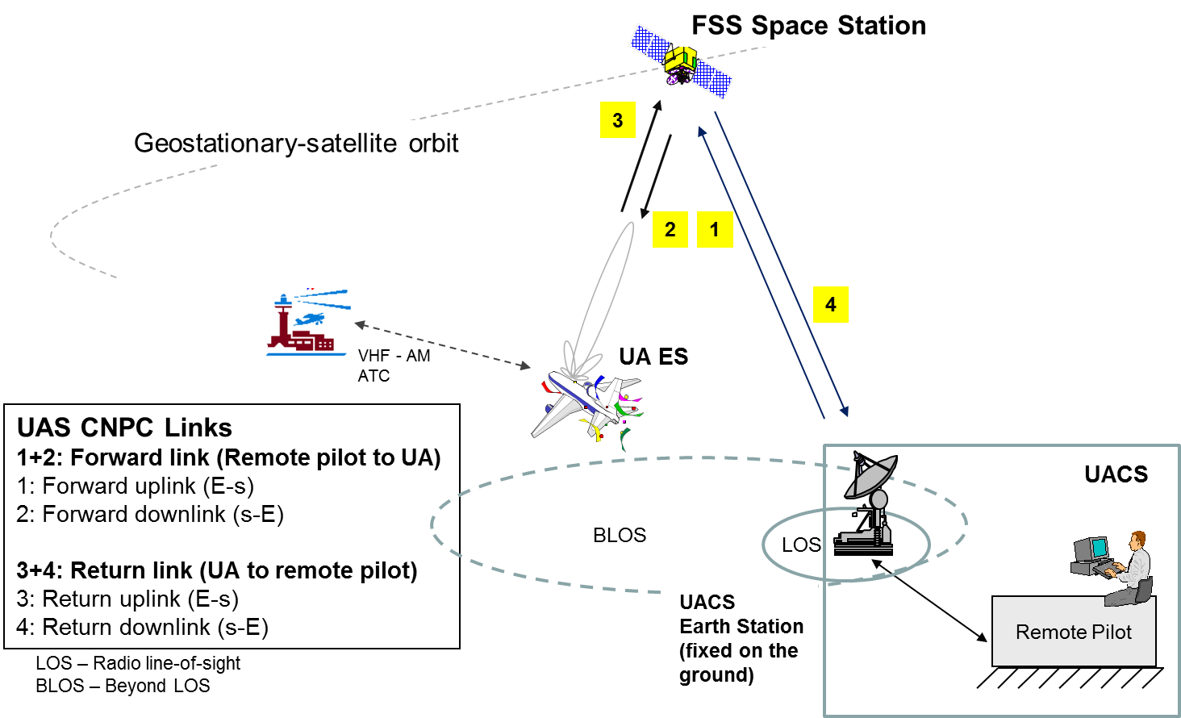

Annex 2 to Resolution [FSS-UA-CNPC] (WRC-15)
Protection of the fixed service and of other fixed-satellite service
networks from UA CNPC emissions

1 Introduction
Because of the fundamental assumption made that to use the frequency bands allocated to the FSS the UAS CNPC link must operate within the same regulatory and performance limitations as any other FSS earth station and that, from an interference perspective, it must perform its function in exactly the same manner as any other FSS earth station, there are only a limited number of additional requirements, over and above those of a typical FSS, that need to be imposed on UAS CNPC operations to ensure compatibility with other services sharing the same frequency bands. These additional requirements are listed in Sections 2, 3, and 4 of this Annex.

2 Protection of the fixed service
The fixed service is allocated by footnotes in several countries with a co-primary status to the FSS. Conditions of UA using CNPC shall be such that the fixed service is protected from any harmful interference as defined below.
1) UA shall not operate at latitudes above 70 degrees.
2) UA shall not operate on frequencies in the band 14.00 to 14.5 GHz in altitudes below 5000 ft.
3) UA shall not operate on frequencies in the band 27.5-29.5 GHz in altitudes below 3000 ft.
4) Earth station on UA shall comply with the two band-specific PFD masks described below.

In the 14-14.5 GHz frequency band as used by fixed service networks, within line-of-sight of the territory of an administration where fixed service networks are operating in this band, the maximum pfd produced at the surface of the Earth by emissions from a single UA should not exceed:

-97 dB(W/(m² ⋅ 14MHz)) | for θ ≤ 5°
-97 + 2.1 ⋅ (θ - 5°)² dB(W/(m² ⋅ 14MHz)) | for 5° < θ ≤ 7.5°
-91.7 - 25 ⋅ log₁₀ (θ) dB(W/(m² ⋅ 14MHz)) | for 7.5° < θ ≤ 53°
-49.7 dB(W/(m² ⋅ 14MHz)) | for 53° < θ ≤ 90°

where θ is the angle of arrival of the radio-frequency wave (degrees above the horizontal).

NOTE 1 The aforementioned limits relate to the pfd and angles of arrival that would be obtained under free-space propagation conditions.

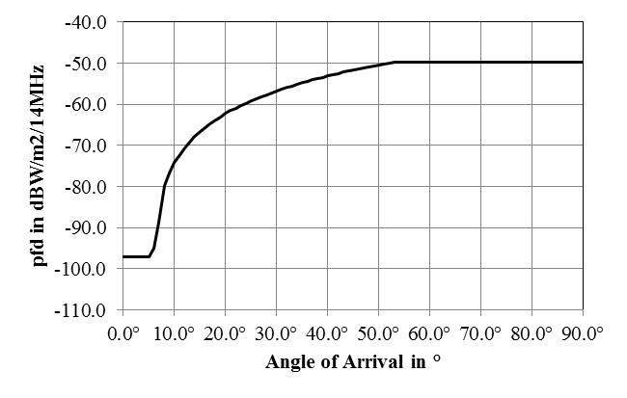
PFD mask as function of angle of arrival for 14.0-14.5 GHz

In the 27.5-29.5 GHz frequency band as used by fixed service networks, within line-of-sight of the territory of an administration where fixed service networks are operating in this band, the maximum pfd produced at the surface of the Earth by emissions from a single UA should not exceed:

-91 dB(W/(m² ⋅ 14MHz)) | for θ ≤ 5°
-91 + 0.6 ⋅ (θ - 5°)² dB(W/(m² ⋅ 14MHz)) | for 5° < θ ≤ 9.4°
-79.4 dB(W/(m² ⋅ 14MHz)) | for 9.4° < θ ≤ 90°

where θ is the angle of arrival of the radio-frequency wave (degrees above the horizontal).

NOTE 1 The aforementioned limits relate to the pfd and angles of arrival that would be obtained under free-space propagation conditions.

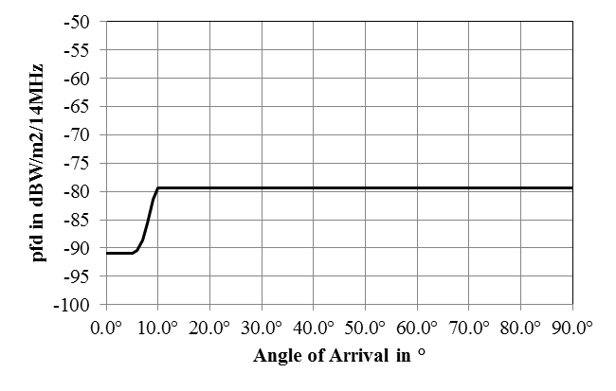
PFD mask as function of angle of arrival for 27.5-29.5 GHz

3 Protection of other fixed-satellite service networks
Conditions of UA using CNPC shall be such that the fixed-satellite service is protected from any harmful interference as defined below.
1) UAS CNPC shall comply with ITU-R S.524, or other coordinated levels agreed between administrations, at all times including when the aircraft is maneuvering.

4 Protection of radio astronomy and other incumbent services as appropriate
In order to protect the radio astronomy in the band 14.47-14.5 GHz, UAS CNPC should comply with both of the following measures:
UAS channels in the 14.47 14.5 GHz band
– UAS CNPC do not transmit in the 14.47-14.5 GHz band within line-of-sight of radio astronomy stations operating within this band;
or,
– if a UAS operator intends to operate co-frequency within the visibility of the radio astronomy station, a specific agreement with the radio astronomy station will be needed to ensure that UAS CNPC will meet the requirements of Recommendations ITU-R RA.769 and ITU-R RA.1513 within the 14.47 14.5 GHz band during observations. Where practicable, this may include advance information to UAS operators regarding observation schedules.
UAS channels in the 14-14.47 GHz band
All UAS CNPC transmitters on channels in the 14-14.47 GHz band within line-of-sight of radio astronomy stations during radio astronomy observations have emissions in the band 14.47 14.5 GHz such that they meet the levels and percentage of data loss given in
Recommendations ITU-R RA.769 and ITU-R RA.1513.

NOTE − Protection measures to be added for other incumbent services as appropriate.

