30 MEETING OF PERMANENT  CONSULTATIVE COMMITTEE II:  RADIOCOMMUNICATIONS  November 27 to December 1, 2017  Barranquilla, Colombia |  | OEA/Ser.L/XVII.4.2.30  CCP.II-RADIO-30/doc. 4356-9-1-4/17  29 November 2017  Original: English
AGENDA ITEM 9.1, ISSUE 9.1.4
PReliminary views FOR WRC-19
 | (Item on the Agenda: 3.1 (SGT2))
 | (Document submitted by the Coordinator)

SGT2A – Radiolocation, Amateurs, Maritime & Aeronautical

Coordinator: Michael Razi (CAN)

Alternate Coordinator: Thomas vonDeak (USA)

Rapporteur Agenda Item: Sandra Wright (USA)

Alternate Rapporteur Agenda Item:

Agenda Item 9: to consider and approve the Report of the Director of the Radiocommunication Bureau, in accordance with Article 7 of the Convention:

Agenda Item 9.1: on the activities of the Radiocommunication Sector since WRC-15.

Note: The subdivision of Agenda Item 9.1 into issues, such as 9.1.1, 9.1.2, etc., was made at the first session of the Conference Preparatory Meeting for WRC-19 (CPM19-1) and is summarized in the BR Administrative Circular CA/226, 23rd December 2015.

Agenda Item 9.1.4: to determine spectrum requirements for sub-orbital vehicles (space planes) and, based on the outcome of those studies, to consider a possible future agenda item for WRC-23

BACKGROUND

Advances in propulsion technology and rocket power has facilitated the design of vehicles which may reach altitudes greater than 100 km, also known as sub-orbital flight, and then return to earth without reaching orbit or deep space. A sub-orbital vehicle may be used for the purposes of commercial space flight, scientific research, point to point travel, cargo transportation, or Earth observation.

Commercial space flight has become a reality with a number of companies promising the chance to experience space flight. These vehicles are currently in their test and development phase. In order to ensure the seamless development and transition to operational use of such vehicles, all of the regulatory issues, including the Radio Regulation provisions, need to be addressed. This agenda item will determine if sub-orbital vehicles (space planes) can be accommodated within existing radiocommunication services and allocations, or if it is necessary that a future WRC define new radiocommunication services and decide on appropriate spectrum allocations to accommodate these vehicles.

Figure 1 shows the approximate distances of the atmospheric layers: the troposphere, stratosphere, and mesosphere. For the purpose of this discussion, the boundary between the Earth’s atmosphere and space is assumed to be 100 kilometers above the Earth’s surface.

Figure 1

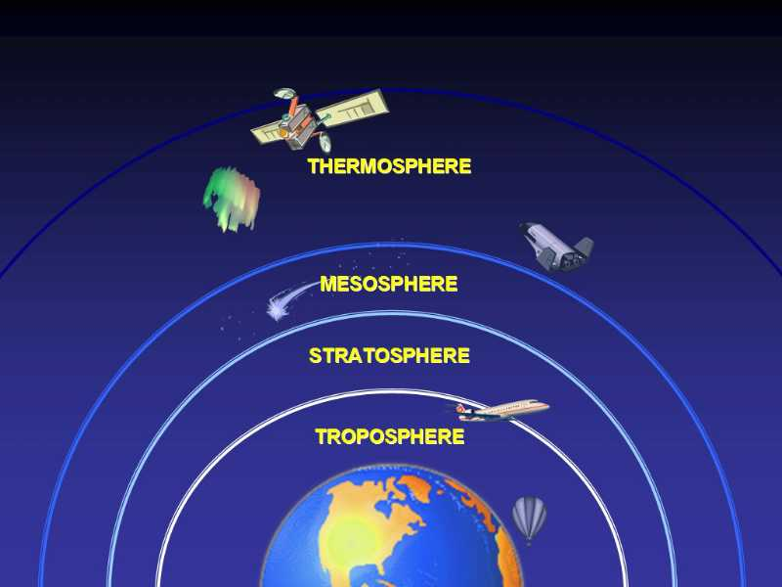
100 km 50 km 10 km 10 km 50 km 100 km
400 km
400 km

Figure 2
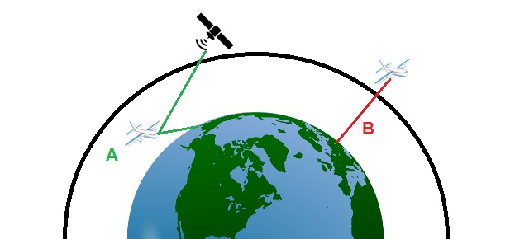
Boundary between space
and the Earth’s atmosphere

Figure 2 shows a sub-orbital vehicle (space plane) in flight below and above the boundary between space and the Earth’s atmosphere.

Resolution 763 (WRC-15) identifies a number of challenges that have to be addressed regarding the spectrum requirements of stations on board sub-orbital vehicles. The ITU Radiocommunication Sector is presently engaged in studying the current and future radio equipage on board sub-orbital vehicles. Studies will be required to identify any required technical and operational measures that could assist in avoiding harmful interference between radiocommunication systems and determine spectrum requirements to consider a possible future agenda item for WRC-23. These studies have been directed to be completed during the WRC-19 study cycle.

[Some initial issues that have been identified regarding spectrum access for sub-orbital vehicles include:

- Is there a requirement for a new radiocommunication system definition for sub-orbital planes?
- Can space planes use existing aeronautical and/or satellite spectrum for their operations?
- If not, is there a need for a future agenda item to identify spectrum for this application?
- The determination of spectrum requirements should take into account considering f) of Resolution 763 (WRC-15). ]

DISCUSSION

[As a first step, it is necessary to address the question of what radiocommunication services are appropriate for stations on-board a sub-orbital vehicle (space plane). During Phase A of flight, the sub-orbital vehicle (space plane) is considered a terrestrial station and therefore could operate radiocommunication stations in terrestrial services. During Phase B of flight, the sub orbital vehicle (space plane) is operating beyond the boundary between the Earth’s atmosphere and space.

Article 1 of the Radio Regulations sets out the terms and definitions used within the Radio Regulations.
Below are questions and answers according to the interpretation of ITU RR Article 1.

Is a sub-orbital vehicle (space plane) a satellite? No, a sub-orbital vehicle (space plane) is not a body which revolves around another body of preponderant mass and which has a motion primarily and permanently by the force of attraction of that other body (RR No. 1.179).

Is a sub-orbital vehicle (space plane) a spacecraft? Yes, it is a man-made vehicle which is intended to go beyond the major portion of the Earth’s atmosphere (RR No. 1.178).

Is a radiocommunication station operating on sub-orbital vehicle (space plane) a space station? Yes, it is a space station because it is located on an object which is beyond, is intended to go beyond, or has been beyond, the major portion of the Earth’s atmosphere (RR No. 1.64).

Is this radiocommunication considered space radiocommunication? Yes, it is considered space radiocommunication because it is any radiocommunication involving the use of one or more space stations or the use of one or more reflecting satellites or other objects in space (RR No. 1.8).

Is this radiocommunication considered radio astronomy? No, radio astronomy is based on the reception of radio waves of cosmic origin (RR No. 1.13).

Figure 3

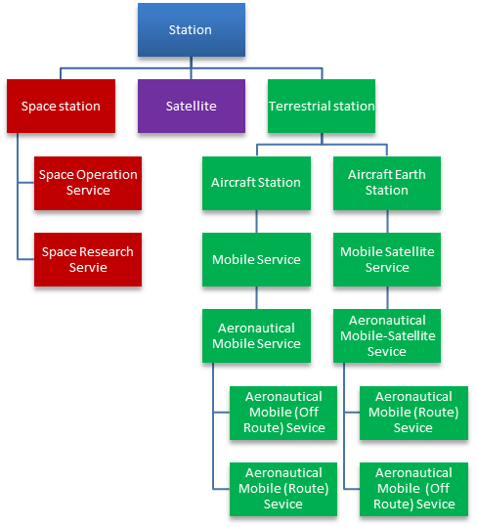
X

At low altitudes (Phase A in Figure 2), sub-orbital vehicles (space planes) are similar to any other aircraft and therefore their radiocommunication stations would be considered an aircraft station or aircraft earth station within the scope of terrestrial stations. Aeronautical services within the mobile service and mobile satellite service would continue to be appropriate for this operation (shown in green in Figure 3).

Once sub-orbital vehicles (space planes) reach altitudes beyond the majority of the Earth’s atmosphere (more than 100 km) they would then be regarded as spacecraft and their radiocommunication stations would be considered a space station since they do not fit the definition of a satellite. As a result, the space station radiocommunication would be regarded as space communication (shown in red in Figure 3).

Does the radiocommunication, beyond the majority of the Earth’s atmosphere, fall within the definition of space operation service? Yes, it is a radiocommunication service concerned exclusively with the operation of spacecraft, in particular space tracking, space telemetry and space telecommand (RR No. 1.23).

Does the radiocommunication, beyond the majority of the Earth’s atmosphere, fall within the definition of space research service? No, the radiocommunication is not used for scientific or technological research purposes (RR No. 1.55).

Given the existing definitions in Article 1 of the Radio Regulations, there seems to be no need for new definitions either for services or stations for sub-orbital vehicles. These vehicles can be accommodated within existing definitions.]

PRELIMINARY VIEW

Canada, USA

- To support studies called for by Resolution 763 (WRC-15), noting that those studies need to be completed during this study cycle.
- Based on the outcome of those studies, consider a possible future agenda item for WRC-23.

Canada

Canada is of the view that existing station and service definitions in Article 1 of the Radio Regulations can be applied to sub-orbital vehicles (space planes).

The boundary between the Earth’s atmosphere and space is sometimes hypothetically assumed to be 100 kilometers above the Earth’s surface, often referred to as the Karman line.

